Title: Requirement Analysis – Online Book Store
Submitted By: Laiba
Internship: 10Pearls SHINE Cohort 9
Learning Path: QA (Manual + Automation)

- Table of Contents
- Project Overview
- User Expectations
- Functional Requirements
- Non-Functional Requirements
- User Stories
- Acceptance Criteria (Gherkin)
- Sprint Planning
- Conclusion

1. Project Overview
The Online Book Store is an online platform where customers can browse, search, and purchase books. Users can create an account, view book details, add books to their shopping cart, and complete their purchases through a secure payment process. The main objective of this system is to make buying books simple, convenient, and reliable for users.
2. User Expectations
Users expect the system to:
- Browse books by category.
- Search for books using the title, author, or genre.
- View detailed information before purchasing.
- Add or remove books from the shopping cart easily.
- Complete payments through a secure checkout process.
- Create and manage their accounts.
- View their previous orders and purchase history.
3. Functional Requirements
The system should:
- Allow new users to register an account.
- Allow registered users to log in securely.
- Display all available books.
- Provide a search option based on title, author, or category.
- Show complete details of each book.
- Allow users to add books to the shopping cart.
- Allow users to remove books from the cart whenever needed.
- Process online payments securely.
- Generate an order confirmation after a successful purchase.
- Allow users to view their order history.

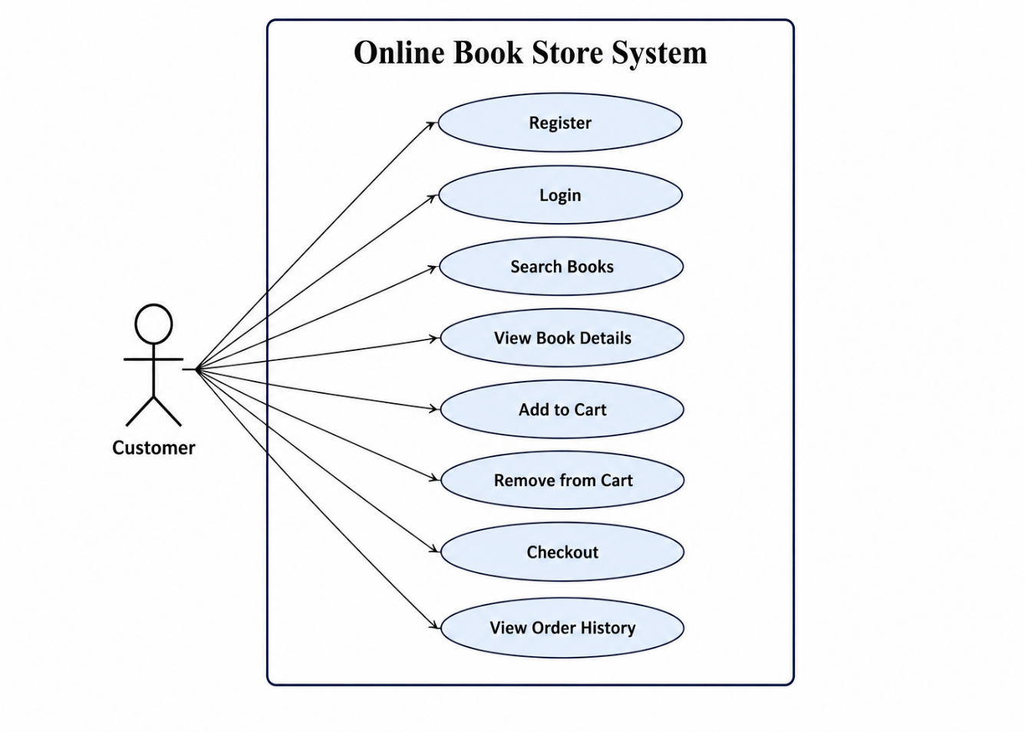
4. Non-Functional Requirements
- Pages should load within 3 seconds under normal conditions.
- User passwords must be stored securely using encryption.
- The system should maintain 99.9% availability.
- The website should work properly on both desktop and mobile devices.
- The system should support multiple users at the same time without affecting performance.
5. User Stories
User Story 1
As a customer, I want to create an account so that I can buy books online.
User Story 2
As a customer, I want to search for books by title so that I can quickly find the book I need.
User Story 3
As a customer, I want to view detailed information about a book so that I can make the right purchase decision.
User Story 4
As a customer, I want to add books to my shopping cart so that I can purchase multiple books in one order.
User Story 5
As a customer, I want to complete my payment securely so that my order is placed successfully.
6. Acceptance Criteria
Scenario 1: User Registration
- Given the user is on the registration page
- When the user enters valid information and clicks Register
- Then the account should be created successfully.
Scenario 2: User Login
- Given the user already has a registered account
- When the user enters valid login credentials
- Then the system should log the user in successfully.
Scenario 3: Search Book
- Given the user is on the homepage
- When the user searches for a book by its title
- Then the system should display the relevant search results.
Scenario 4: Add to Cart
- Given the user is viewing a book
- When the user clicks Add to Cart
- Then the selected book should be added to the shopping cart.
Scenario 5: Checkout
- Given the shopping cart contains one or more books
- When the user completes the payment successfully
- Then the system should display an order confirmation message.
7. Sprint Planning
Sprint | Duration | Tasks
Sprint 1 | Week 1 | Requirement Analysis & User Stories
Sprint 2 | Week 2 | UI Design & Database Design
Sprint 3 | Week 3 | User Registration & Login
Sprint 4 | Week 4 | Book Search & Shopping Cart
Sprint 5 | Week 5 | Checkout & Payment
Sprint 6 | Week 6 | Testing & Bug Fixes

8. Conclusion
This requirement analysis outlines the main features and expectations of the Online Book Store system. Defining the functional requirements, non-functional requirements, user stories, and acceptance criteria helps ensure that the application meets user needs and provides a secure, reliable, and user-friendly experience. It also serves as a strong foundation for development and software testing.

